 | Laser measurement systems.  Microprocessor controllers  . | Research and Developement Company  Lasertex Co. Ltd.  ul.Swojczycka 26, 51-501 Wrocław  tel. +48-509-495-023  +48-71-372-43-06  email: lasertex@lasertex.eu  fax (0-71) 202334

Right Angle Etalon set – RE3D

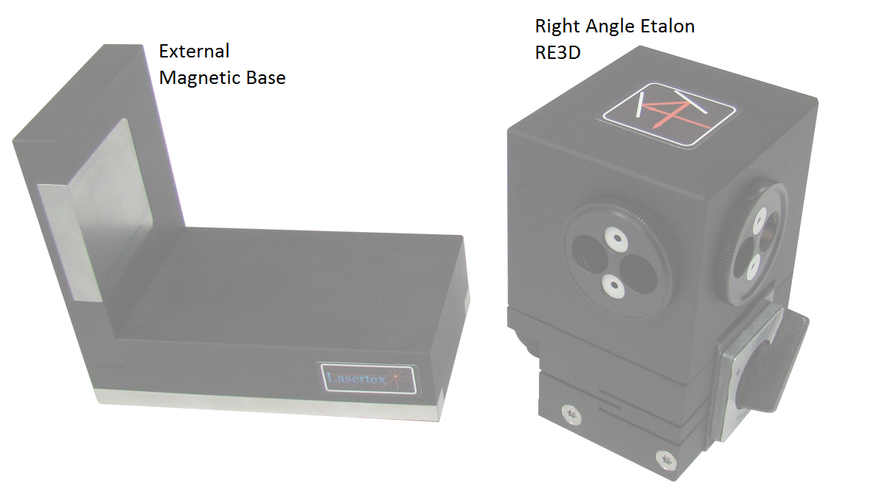

Right Angle Etalon RE3D can be used to measure squareness in the same plane as a laser head base or in perpendicular plane to the laser head using external magnetic base. Thanks to the special set of inside mirrors the output beam, is always reflected at 90° according to the incident beam. As long as you place all Lasertex elements at the same plane you don't have to adjust their hight, we made it for you. We recommend you to set Right Angle Etalon RE3D after the Linear Interferotemer IL1.

Sqaurnes measurement in perpendicular plane to the laser head (X-Z Axis)

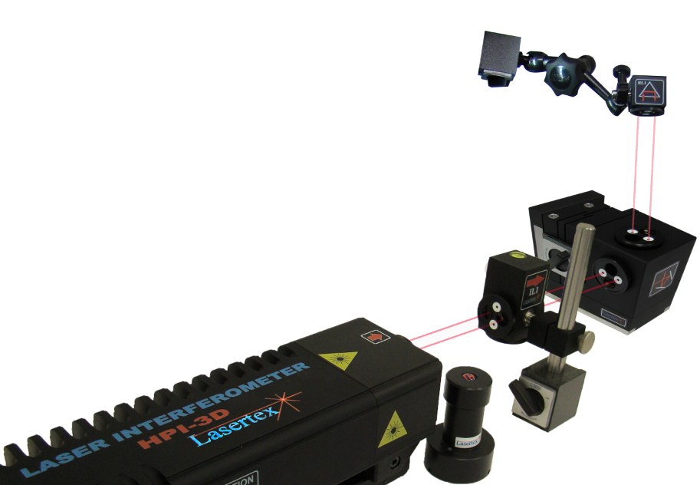

Sqaurnes measurement in normal plane to the laser head (X-Y Axis)

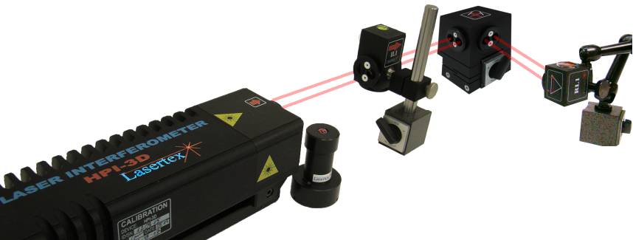

Adjustment
For perfect beam alignment please use adjustment screw A to diminish the angle shift a in the referance plane Y.

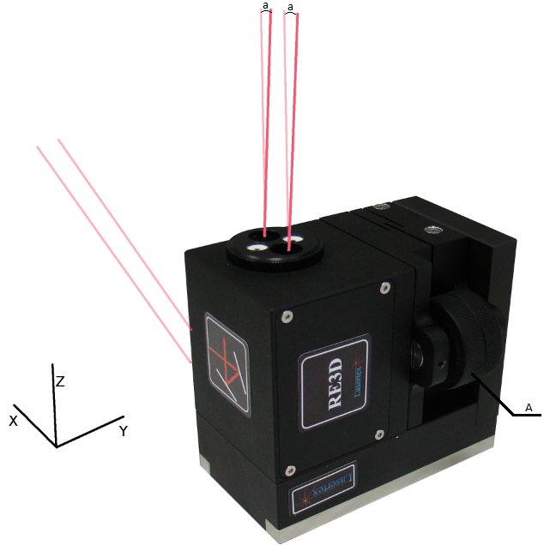

The price includes:
- Warranty – 12 month (the warranty service will be performed by Lasertex in Poland)

